Lab 2 CCS3101
28 March 2025
- Solve the following question and demonstrate your solution to me in this lab, the next lab (preferred) or at the the start of the lab after next. This is a 2-weeks lab. For record-keeping, submit also your solution and screenshots of its output to PutraBlast.
- Evaluation will be done according to the lab rubric on PutraBlast. I will ask questions accordingly.
*******************************

Question:

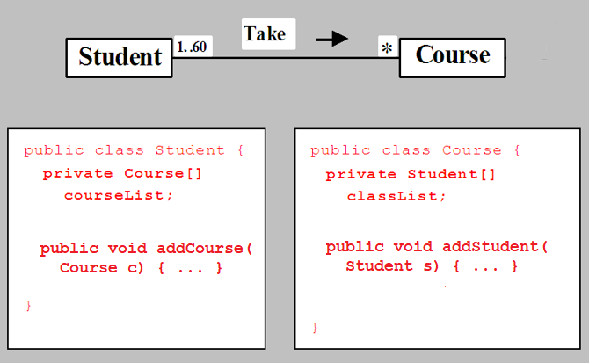

Implement the above classes. For each class, add 1 additional data field for the student/course name. Define constructors, setters and getters as needed.

Note that for consistency, if you add a Student to a Course, you must also add the Course to the Student, and if you add a Course to a Student, you must also add the Student to the Course. You should use the this reference variable for this, but be careful that you don't get into an infinite loop (hint: try to find a way so that you don't add the same course or student twice).

Test your classes as follows:
- Create 2 Student objects named Peter Jones and Kim Smith, and 2 Course objects named Data Structures and Database Systems.
- Assign both Peter Jones and Kim Smith to the Data Structures course, and Kim Smith to the Database Systems course.
- Print, using the objects of step 1:
  - The course(s) that Peter Jones and Kim Smith are taking.
  - The student(s) in the Data Structures and Database Systems course.

(The figure is based on a figure in the 10th edition of the Liang textbook. A similar figure is in the 11th edition).

